Name of Teaching  Staff | Prof. Divya Jyothi Bhandary |  |  | 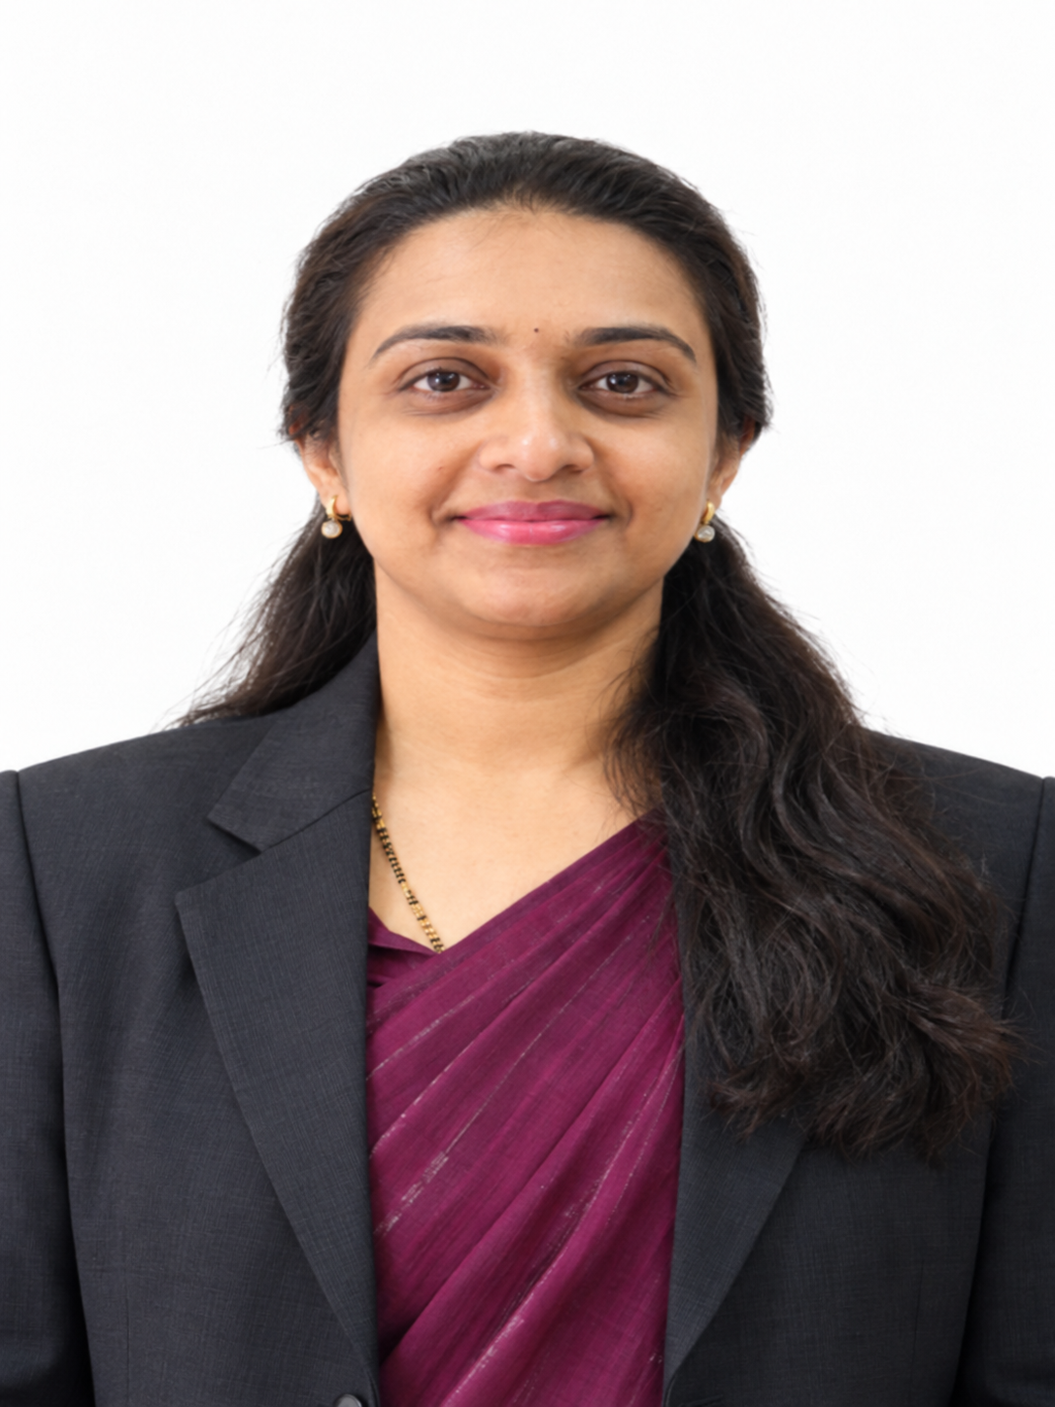
Institute Name | PDEA`s Institute of Technical Education Research and Management, Akurdi, Pune.
Designation | Assistant Professor
Department | MBA
Area of Specialization | Finance
Date of Joining the Institute | 21/09/2026
Qualifications with Class/Grade | PG  MBA | First Class | UG  BBA | First Class | Other
Total Experience in Years | Teaching | 2.5 years | Industry | 14 years | -
Paper Published | International | - | National | - | -
Books Published

